Week 3 Homework:
Read/Write Files:
By Lauren Geislinger
09/13/2020

I reused some assets from the in-class assignment for the homework. I first replaced my data txt file with the information for the homework:

NAME, ADDRESS, PHONE
DAVID SMITH, 1230 LANE STREET, 678-9080
JOHN SMITH, 1230 LANE STREET, 678-9080
MARY SMITH, 1230 LANE STREET, 678-9080
SANDY SMITH, 1230 LANE STREET, 678-9080
MIKE MOORE, 4567 SPORTY STREET, 678-5678

Next, I ran my FileIO.java project. The output printed the file text to the screen but did not have line numbers.

I created an integer in a for loop called a, and decided to increment it for the line numbers. This did not work initially.
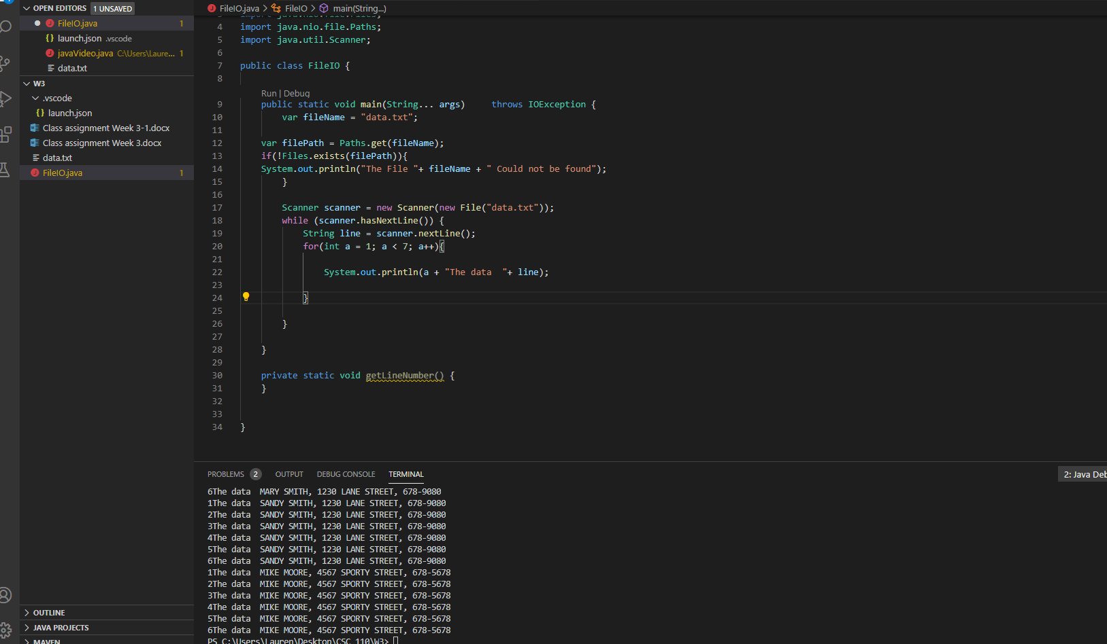

The number did increment but since it was running during the while loop, the lines would repeat 6 times. Also, there was no space between the number and “the data”.
I deleted my int a, and I created an integer for the line numbers called lineCount and started it at 1.
I also created this integer outside of the while loop, because it seemed like that was causing the issue.

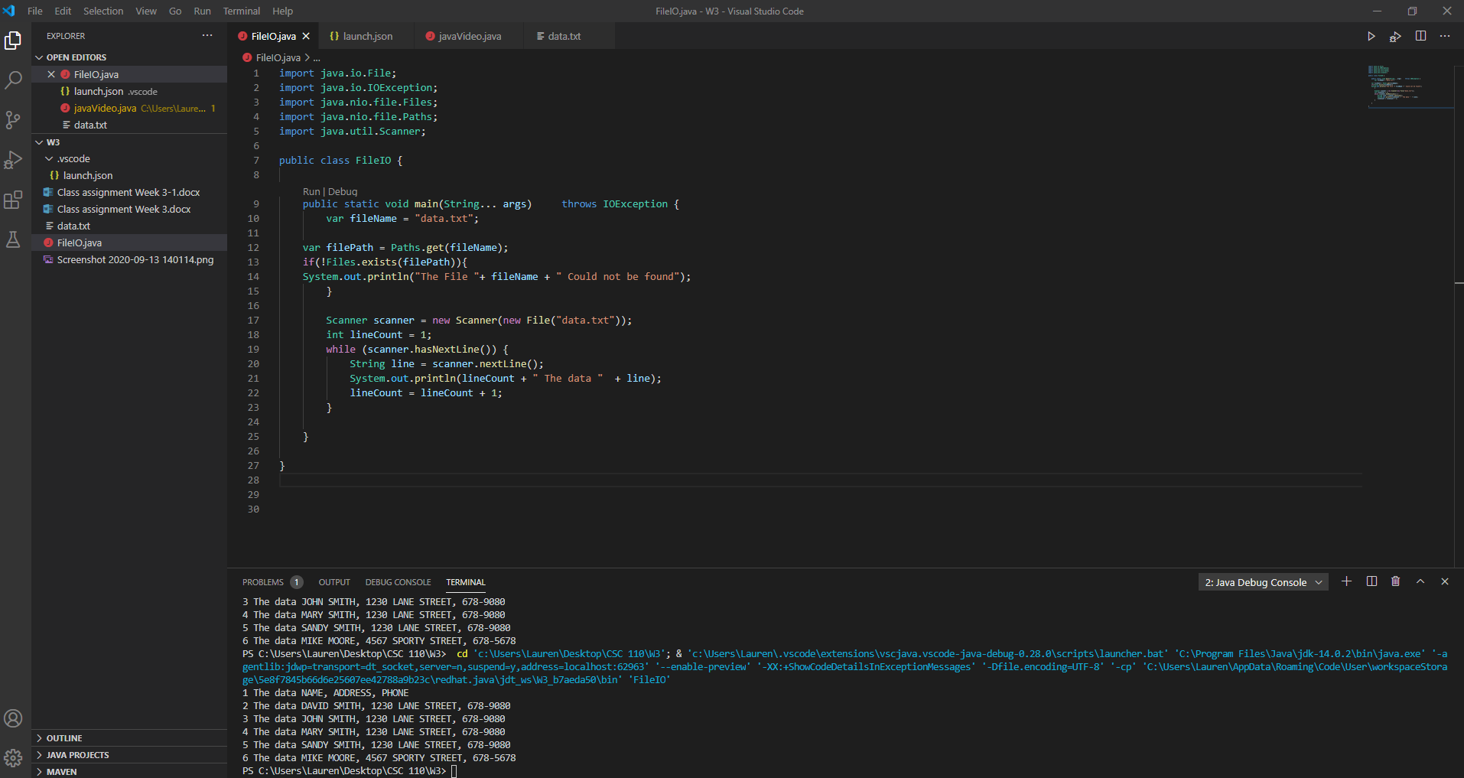
I incremented lineCount by doing lineCount = lineCount + 1; into the while loop, but created the variable outside of it. I could have also done this as System.out.println(lineCount++ + “ The Data “ + line); or just lineCount++. I also added a space in “ The data “ for the space between the number and the start of the data.

